Pepe meamea in the spirit of the collective:
Embedding Samoan indigenous philosophy in ECE for Samoan children under two

Jacoba Matapo, Salā Pafitimai Fa’asaulala Tagoilelagi-Leota, Tafili Utumapu-McBride, and Meiolandre Tima Project dates: 10 December 2020 – 31 March 2023

Project description: This 2-year study with Samoan full immersion and bilingual Aoga Amata centres and English-medium ECE centre partners that engaged Samoan and non-Samoan faiaoga/teachers of pepe meamea (Samoan infants and toddlers) in cross-sector community partnerships. The study drew from Samoan indigenous knowledge systems, values, and practices to inform the research design, process, analysis, and dissemination. One product of this research, the pepe meamea framework, emerged through ongoing talanoa and engagement in Samoan cultural pepe meamea practices. The framework seeks to advance Samoan knowledge systems and practices conducive to the ola laulelei (cultural wellbeing) and belonging of pepe meamea. As an indigenous-based ECE study, the research contributes to ECE scholarship in both Aotearoa New Zealand and Samoa.
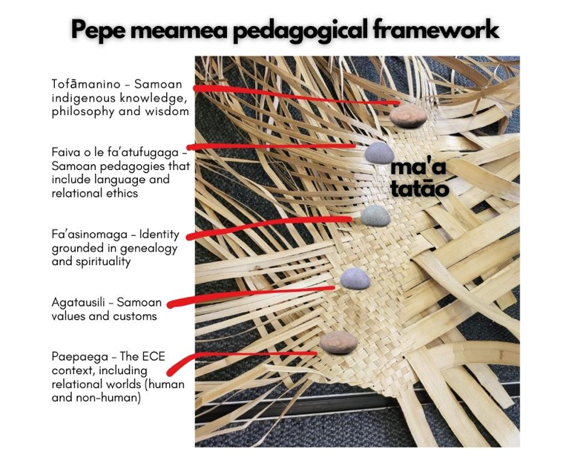
Aims: This research aimed to develop a Samoan pedagogical framework for pepe meamea that is reflective of the complex realities of Samoan children in Aotearoa New Zealand and is culturally sustaining for their wellbeing. The holistic framework is guided by Samoan indigenous knowledge and practice and depicted as a fala pepe (Samoan baby mat) in progress, secured by ma’a tatāo (securing rocks). This framework provides cultural touchstones relevant to all early childhood teachers in their pepe meamea pedagogy.

Our partners:
SAASIA (Sosaiete Aoga Amata Sāmoa I Aotearoa Incorporated)
Aoga Amata ECE partners: ECE Centre partners:
Seugagogo Aoga Amata Otahuhu Happy Feet Childcare
Fotumalama Aoga Amata Toddlers Turf
Taeaofou i Puaseisei Presschool (Raglan Street) Immanuel Preschool Mangere East
Fetu Taiala Aoga Amata Pukeko Preschool
Tumanu Ae Le Tu Logologo Aoga Amata Inspire Early Learning Papakura
Taeaofou i Puaseisei Preschool (Winthrop Way) Barnardos Early Learning Mangere

Research questions:
1) What is pepe meamea, and how is it grounded in Samoan indigenous knowledge systems and ontology?
2) How is pepe meamea pedagogy understood and practised within Samoan Aoga Amata communities?
3) How effective are cross-cultural mentoring partnerships between Samoan Aoga Amata and English-medium ECE centres in fostering culturally sustaining pedagogies through the indigenous Samoan framework of pepe meamea?
4) How has teacher engagement with Samoan indigenous knowledge systems and the framework of pepe meamea transformed pedagogy to enhance the ola laulelei (cultural wellbeing) of Samoan infants and toddlers?

Key findings:
- The pepe meamea framework offers teachers new ways of framing infant and toddler pedagogies that differ from Eurocentric methods.
- The five ma’a tatāo (touchstones) provide all early childhood teachers of pepe meamea secure points from which to examine culturally sustaining practices and engender co-agentic practices with pepe meamea and their fanau.
- The cross-cultural mentoring between faiaoga and ECE teachers resonated with the metaphor of fenū; the carefully chosen strand of loose laufala (pandanus strip) used to continue the weaving of the fala pepe. Fenū is key to its strength and integrity, without which the fala pepe cannot be completed. In the mentoring relationships of this research project, faiaoga found it helpful to see themselves as the fenū for the teachers from English-medium settings.
Ola laulelei (Cultural wellbeing): In the context of the study, faiaoga and teachers reflected on the transformation of their pedagogy to engage the pepe meamea framework in practice, curriculum design and philosophy. Pepe meamea have accessed cultural resources, such as the fala pepe (Samoan baby mat), as a physical and spiritual connection to their fanua (Samoan land). An outcome of this research is that the ola laulelei of pepe meamea is now better recognised by non-Samoan teachers as a product of a continuous journey and is understood as a shared responsibility of aiga (family), nu’u (villages) and ECE centre communities.

Implications: Throughout the study, it was apparent that it is vital for all ECE teachers of pepe meamea to understand the complexities of their Samoan community in terms of cultural access and aspirations and to recognise that not all fanau speak Samoan or have access to cultural knowledge. Participating teachers affirmed that ECE teachers consulting with aiga and fanau regarding pepe meamea pedagogy benefit from being open to understanding Samoan early childhood ontologies, which may be dissimilar to normative ideologies or Eurocentric child-rearing practices and are tied to ancestral practices and wisdom that can enhance the ola laulelei of pepe meamea. Although the study provided valuable initial insights into the pepe meamea pedagogical framework, extended research will further illuminate its long-term benefits, particularly its positive influence on the ola laulelei of pepe meamea.

