Nurturing secondary students’ hope and agency: Educating to live in a climate-impacted world

Sally Birdsall, Chris Eames, Sarah Gaze, Graham Stoddard, Niki Harré, Hilary Whitehouse and Charlotte Blythe Project dates: January 2021-November 2023

Intro / Project description
Today’s youth will be severely impacted by climate change and many are feeling anxious, hopeless and helpless. More than knowledge is needed to help them be citizens who can make informed
decisions to mitigate its effects. Hope and agency have been identified as significant qualities that can overcome pessimism and hence the partners in this project co-designed a climate change education programme to nurture students’ hope and agency, creating opportunities for them to take action individually and collectively.

Aims
The aim of this project was to develop a hopeful climate change programme. Its goal was to develop secondary students’ understanding about the science of climate change, to learn about action-taking that could mitigate the effects of climate change and help them to feel more hopeful about their future. As a result of their learning, we hoped young people could believe they could contribute meaningfully at both an individual and community level when dealing with the current climate emergency.

Why is this research important?

Our world is now experiencing the emergencies of climate change. It is the next generation who will be the most impacted by these emergencies, physically, emotionally and financially. Consequently, we have a moral imperative to prepare young people to cope in a world impacted by the detrimental effects of these climate-related emergencies. Recent research suggests that students need more than knowledge; they need hope for their futures. There are indications that feeling hopeful about the future is influenced by agency or knowing how to take action. This project sought to explore this relationship.

Key findings
Two classes of students took part. One class were Year 10 students (14-15 year olds) and the other Year 12 and 13 students (16-18 year olds). The climate change education programme did seem to have some effect on students’ learning. Both groups reported growth in their understanding of the science and effects of climate change, with the younger students reporting the most growth. Regarding their perceptions of agency, the younger students identified an upward trend with comments suggesting that they now knew how they could take action to mitigate climate change’s effects and about collective agency being critical in making a difference. The older students reported a smaller upward trend, and some questioned the efficacy of individual actions, doubting their ability to bring about societal change. In both classes, perceptions of hope changed the least and were mixed. Sources of hope were identified, such as inspiring class content and learning about people who were making a difference. Negative comments despaired about people who were reluctant to make changes, berating governments and corporations for not making changes quickly enough, and the problems of connecting to the urgency, scope, human complicity and visibility of impacts. There seemed to be possible relationships between understanding, agency and hope. Greater understanding seemed to lead to feeling more agentic. The relationship between agency and hope seemed mutually reinforcing. As students felt more agentic, they felt more hopeful. However, knowing more about climate change led to students feeling both hopeful and hopeless. More research is needed to explore these relationships for effective learning about climate change.

Implications for practice

Students need:
- To develop understanding about climate change, particularly scientific, but also about the social, cultural, and economic structures in which people are entangled and how these entanglements impact on managing the effects of climate change at a community, regional and national scale.
- To learn the skills to be individually and collectively agentic towards climate change.
- Well-being support to cope with the climate-related emotions that they are feeling.
Teachers need:
- Professional learning in order to engage in the interdisciplinary teaching required.
- Professional learning in order to support students’ climate-related emotions.
- To provide opportunities for students to engage in action-taking projects that are meaningful and relevant to their lives.
At a school and policy level:
- Age-appropriate resources that support teacher and student knowledge development are needed.
- Schools need to enable students to engage in action-taking projects.
- School counsellors and other support networks might need training to provide support for students’ climate-related emotions.
- Schools need to consider how assessment impacts on the development of understanding, agency, and hope for climate change. For example, if the necessity to complete Achievement Standards is diverting attention from the development of agency, then consideration needs to be given to how Achievement Standards could be changed to enhance students’ agency to act on the effects of climate change.
Our partners:
Associate Professor Chris Eames - Co-investigator
Ms Sarah Gaze - Teacher Practitioner
Mr Graham Stoddard - Teacher Practitioner
Professor Niki Harré - Expert Consultant
Associate Professor Hilary Whitehouse - Critical Friend
Dr Charlotte Blythe - Research Assistant
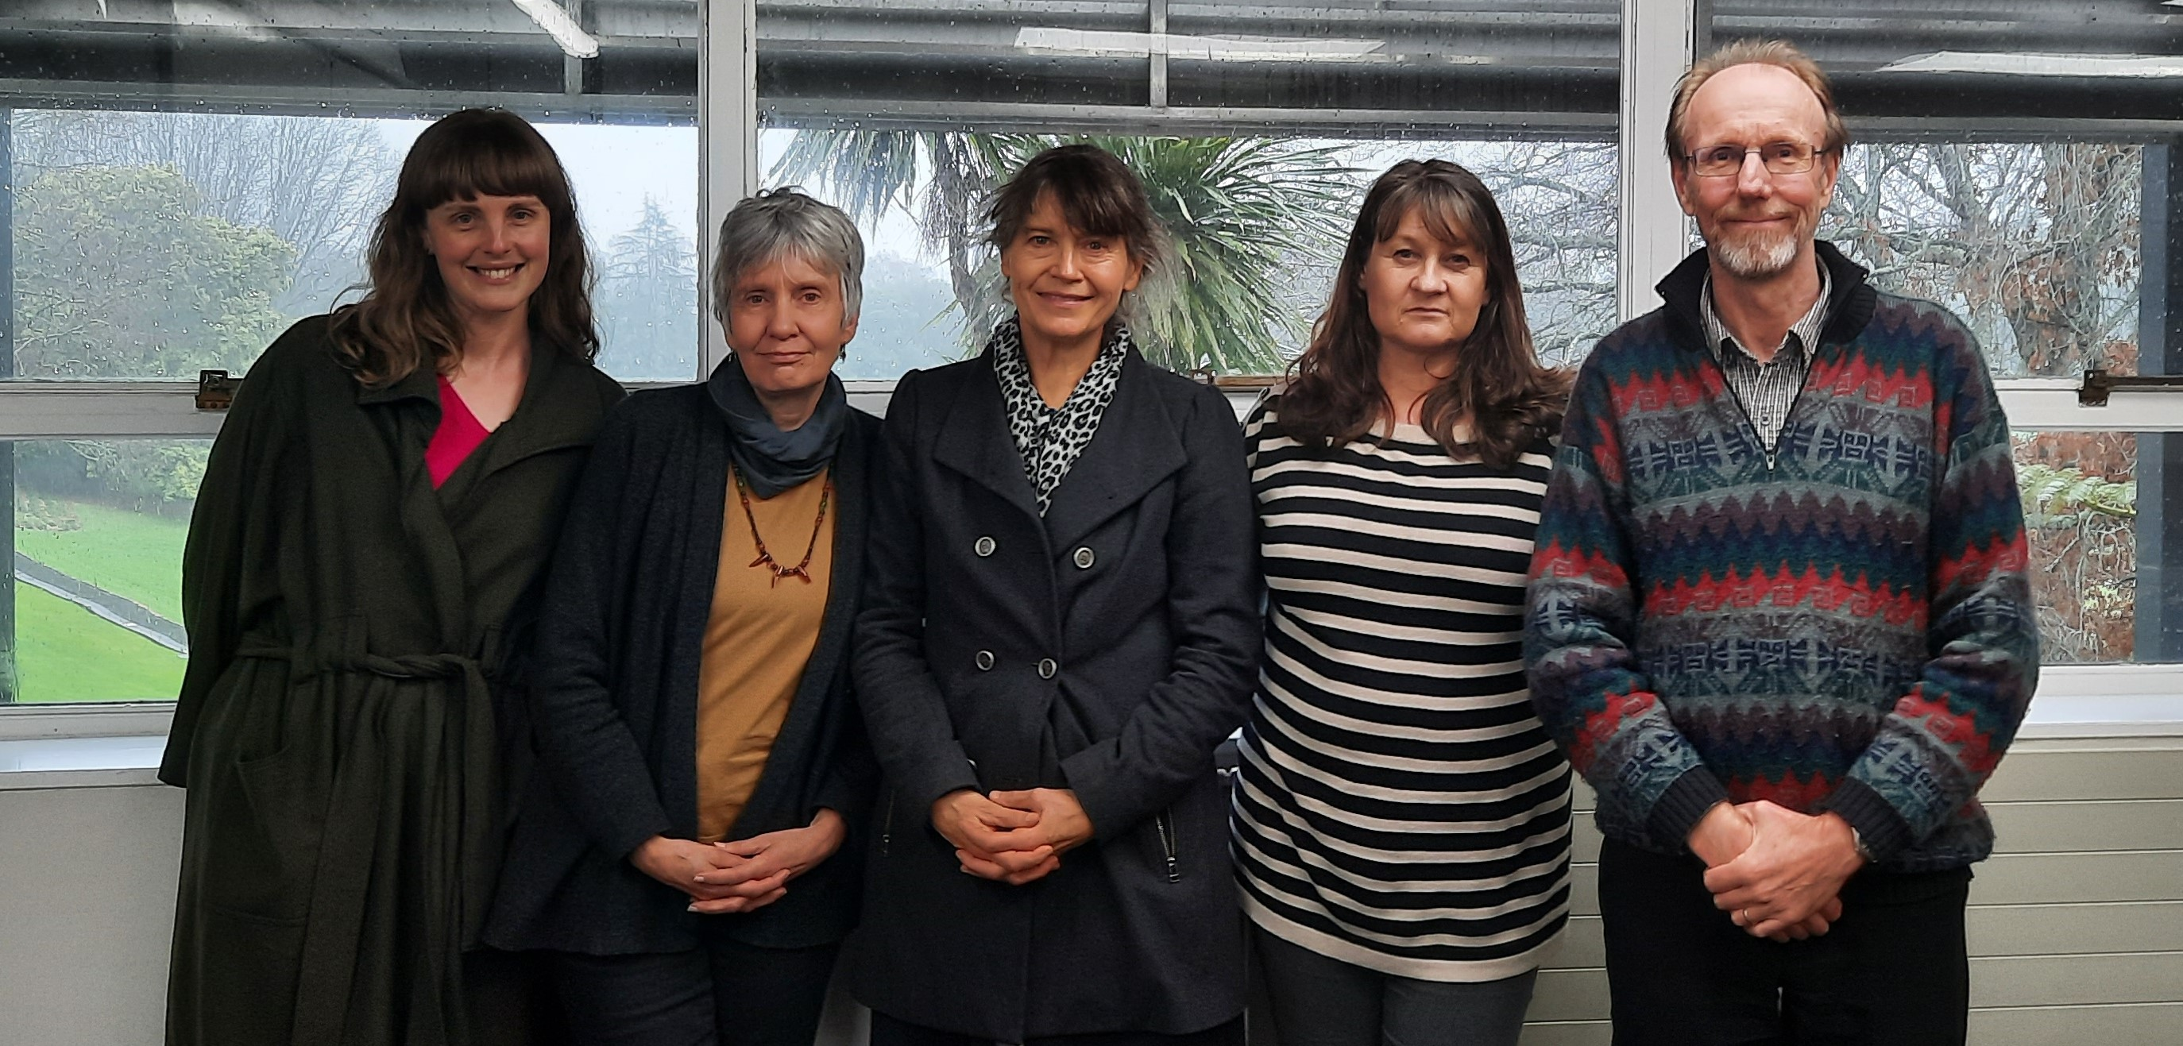

Contact details:
Sally Birdsall - s.birdsall@auckland.ac.nz
Chris Eames
chris.eames@waikato.ac.nz

